Project Development Phase Model Performance Test

Date | 12 Feb 2025
Team ID | LTVIP2026TMIDS91693
Project Name | Exploratory analysis of rain fall data in  India for agriculture
Maximum Marks | 10 Marks

Model Performance Testing:
Project team shall fill the following information in model performance testing template.

S.N  o. | Param eter | Values | Screenshot
1 | Metric s | Regression Model:  MAE = 0.32  MSE = 0.21  RMSE = 0.46  R² Score = 0.81 Classification Model: Confusion Matrix = [[21220 857 61]  [3598 2639 75]  [358 74 310]  Accuracy Score = 0.83  Classification Report = Precision  = 0.81  Recall = 0.83  F1-Score = 0.81 | 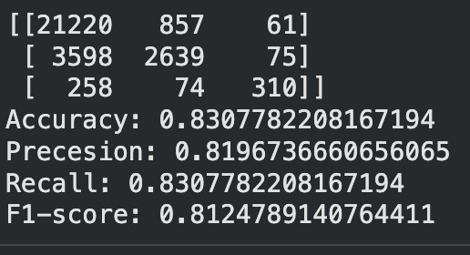
2 | Tune the Model | Hyperparameter Tuning: Grid Search was used to optimize model parameters such as number of trees and maximum depth. Validation Method: K- Fold Cross Validation (k = 5)

